## discrete uniform distribution:

 is a [symmetric](https://en.wikipedia.org/wiki/Symmetric_distribution) [probability distribution](https://en.wikipedia.org/wiki/Discrete_probability_distribution) wherein a finite number of values are equally likely to be observed; every one of *n* values has equal probability 1/*n*. Another way of saying "discrete uniform distribution" would be "a known, finite number of outcomes equally likely to happen.

## Definition:

A uniform discrete random variable is a type of random variable where each outcome in its range has an equal probability of occurring.

# Importance:

Uniform discrete random variables are commonly used in various fields, including statistics, probability theory, and computer science. Understanding their properties is crucial for modeling certain types of phenomena.

# Properties of Uniform Discrete Random Variables:

# Probability Mass Function (PMF):

The PMF of a uniform discrete random variable is constant for all values in its range. It is defined as:

P(X= *x*)=1/n, for  *x* in the range of  *X* where n is the number of possible outcomes

And *n* = *b* − *a* + 1.

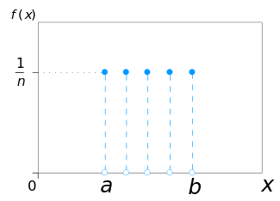

### Expected value and variance:

The expected value and variance are two statistics that are frequently computed. To find the variance, first determine the expected value for a discrete uniform distribution using the following equation:

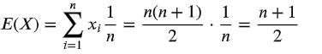

The variance can then be computed as:



where  and f(x) is the probability mass function (pmf) of a discrete uniform distribution, or 1/n Thus:

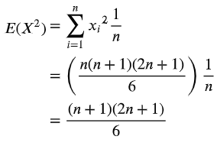

|  |  |
| --- | --- |
| The variance can then be found by plugging E(X2) and [E(X)]^2 into the above equation: |  |
|  |  |
|  |  |
| * **Cumulative mass function(CMF):**    the [cumulative distribution function](https://en.wikipedia.org/wiki/Cumulative_distribution_function) (CDF) of the discrete uniform distribution can be expressed, for any *k* ∈ [*a*,*b*], as:    https://www.statisticshowto.com/wp-content/uploads/2013/09/uniform-cdf.gif  **Discrete Uniform Code Implementation:** |  |

* 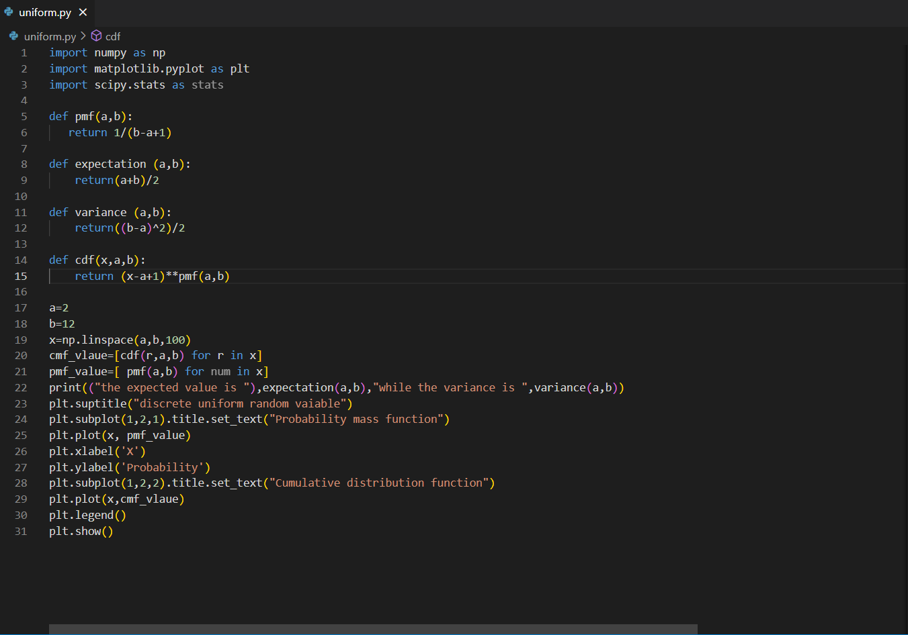**pmf(a, b):** This function calculates the probability mass of a given value x in the uniform distribution defined by lower limit a and upper limit b. The PMF is simply 1/(b-a+1), which means all values within the range have an equal probability of occurring.
* **expectation(a, b):** This function calculates the expected value of the uniform distribution. The expected value is the average of all possible values, and for a uniform distribution, it is simply the average of the lower and upper limits: (a+b)/2.
* **variance(a, b):** This function calculates the variance of the uniform distribution. The variance is a measure of how spread out the values are, and for a uniform distribution, it is calculated as (b-a)^2/2.
* **cdf(x, a, b):** This function calculates the cumulative distribution function (CDF) of the uniform distribution. The CDF is the probability that a value will be less than or equal to x. For a uniform distribution, the CDF is (x-a+1) * pmf(a, b).
* **numpy:** This library is used for scientific computing and provides efficient data structures and mathematical operations. In this code, it is used to create the x array of evenly spaced values between the lower and upper limits of the distribution and for mathematical calculations like calculating the variance.
* **matplotlib.pyplot**: This library is used for creating visualizations. In this code, it is used to plot the PMF and CDF of the uniform distribution. It provides functions for creating different types of plots and customizing their appearance.
* **scipy.stats**: This library provides a collection of statistical functions and distributions. In this code, it is not used directly, but it is a dependency of the pmf function, which uses the stats.uniform function to calculate the PMF of the uniform distribution.

# Code Explanation:

* cmf_vlaue=[cdf(r,a,b) for r in x]:
* This line calculates the CDF for each element r in the x array. The CDF tells you the probability that a value will be less than or equal to r.
* By calculating the CDF for each element in x, you get a complete picture of the distribution of probabilities across the entire range of the uniform distribution.
* This can be useful for tasks like calculating the probability of a certain event happening, or finding the quantiles of the distribution.
* pmf_value=[ pmf(a,b) for num in x]:
* This line calculates the PMF for each element num in the x array. The PMF tells you the probability of a specific value occurring.
* Calculating the PMF for each element in x allows you to see how the probability is distributed across the different values within the range of the uniform distribution.
* This can be useful for tasks like understanding which values are more likely to occur, or calculating the expected value of the distribution.
* plt.suptitle("discrete uniform random vaiable"):

This line adds a title to the overall figure, indicating that it's showing a discrete uniform random variable.

* lt.subplot(1,2,1).title.set_text("Probability mass function"):

This line creates a subplot on the left side of the figure and sets its title to "Probability mass function" (PMF).

* plt.plot(x, pmf_value):

 This line plots the PMF of the uniform distribution. The x array contains the possible values, and the pmf_value array contains the corresponding probabilities for each value.

* plt.xlabel('X')**and**plt.ylabel('Probability')**:**

These lines label the X and Y axes of the PMF plot.

* plt.subplot(1,2,2).title.set_text("Cumulative distribution function")**:**

This line creates a subplot on the right side of the figure and sets its title to "Cumulative distribution function" (CDF).

* plt.plot(x,cmf_vlaue)**:**

This line plots the CDF of the uniform distribution. Similar to the PMF plot, x contains the possible values and cmf_vlaue contains the corresponding probabilities for each value being less than or equal to the corresponding x value.

* **plt.legend():**

This line adds a legend to the CDF plot, which can be helpful if you have multiple lines plotted.

* **plt.show()**:

This line displays the entire figure with both the PMF and CDF plots.

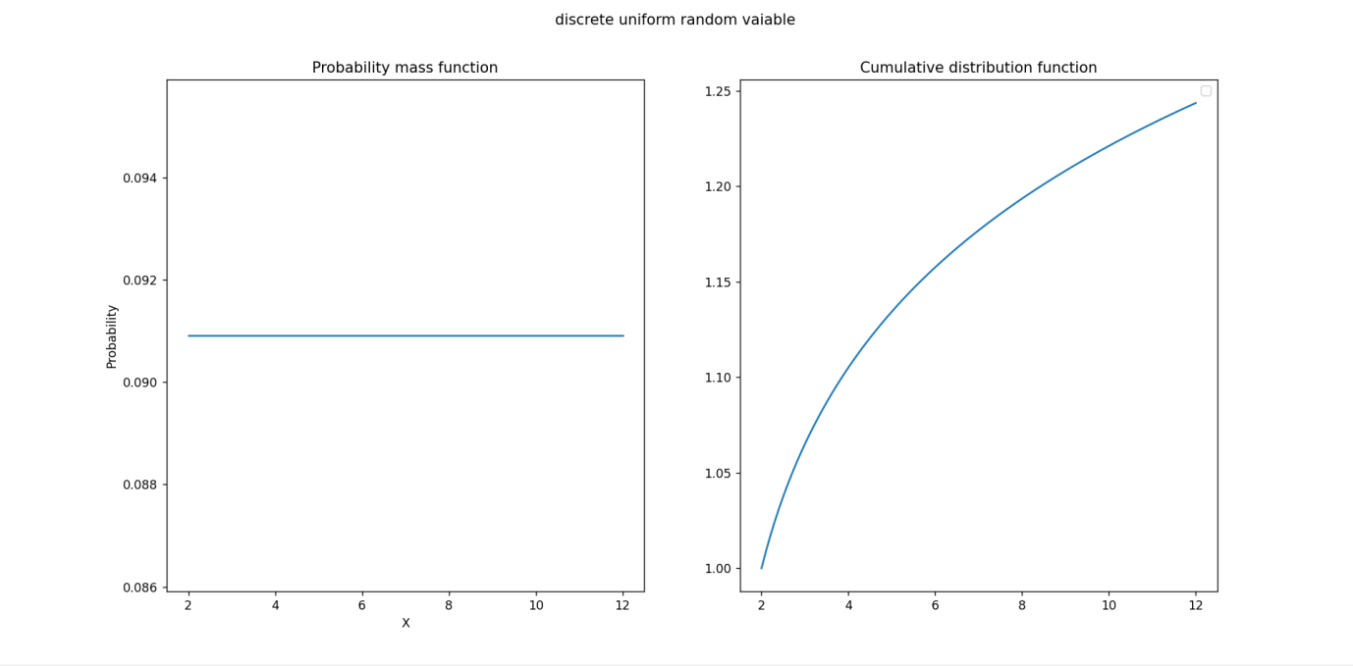

### Conclusion

Uniform discrete random variables provide a simple and powerful way to model situations where each outcome is equally likely. Understanding their properties is essential for various applications in probability theory and statistics.